**ECOBIN: SMART WASTE MANAGEMENT WITH ODOR &**

**GPS TRACKING**

**INNOVATIVE PROJECT**

**April/May 2025**

PROJECT WORK

**INNOVATIVE / MULTI-DISCIPLINARY PROJECT** REPORT SUBMITTED IN PARTIAL FULFILLMENT OF THE REQUIREMENTS

FOR THE AWARD OF THE DEGREE OF **BACHELOR OF ENGINEERING**

IN **ELECTRONICS AND COMMUMICATION ENGINEERING**

OF THE ANNA UNIVERSITY



Submitted by

**ABINAV G – 722822106002**

**DHAUSHWARAN S – 722822106023**

**HANSHAN KUMAR B – 722822106038**

**INBAARUNRAJ D – 722822106047**

**BATCH 2022 – 2026**

Under the Guidance of

**Ms. T. Nivethitha, M.E., (Ph.D).,**

**Assistant Professor / ECE**

**Sri Eshwar College of Engineering**

(An Autonomous Institution)

Kinathukadavu (Tk), Coimbatore - 641 202, Tamil Nadu

Approved by AICTE, New Delhi and Affiliated to Anna University, Chennai



# BONAFIDE CERTIFICATE

Certified that this Report titled **“ECOBIN: Smart Waste Management With Odor & Gps Tracking”** is the bonafide work of

|  |  |
| --- | --- |
| **ABINAV G** | **722822106002** |
| **DHANUSHWARAN S** | **722822106023** |
| **HANSHAN KUMAR B** | **722822106038** |
| **INBAARUNRAJ D** | **722822106047** |

who carried out the project work under my supervision.

**SIGNATURE SIGNATURE**

**Dr. N. Shanmugasundaram, M.E., Ph.D.,**

**HEAD OF THE DEPARTMENT**

Professor & Head, Department of ECE,

Sri Eshwar College of Engineering, Coimbatore – 641 202.

**Ms. T. Nivethitha, M.E., (Ph.D)., SUPERVISOR**

Assistant Professor, Department of ECE,

Sri Eshwar College of Engineering, Coimbatore – 641 202.

Submitted for the **Autonomous Semester End Innovative / Multi-Disciplinary Project Viva-Voce** held on ………………….

**INTERNAL EXAMINER EXTERNAL EXAMINER**



**QUALITY POLICY**

To establish a system of Quality Enhancement, which would on a continuous basis evaluate and enhance the quality of teaching – learning, research and extension activities of the institution, leading to improvements in all processes, enabling the institution to attain excellence.

**INSTITUTE VISION**

To be recognized as a premier institution, grooming students into globally acknowledged engineering professionals.

**INSTITUTE MISSION**

* Providing outcome and value-based engineering education
* Nurturing research and entrepreneurial culture
* Enabling students to be industry ready and fulfill their career aspirations
* Grooming students through behavioral and leadership training programs
* Making students socially responsible

**DEPARTMENT OF ELECTRONICS AND COMMUNICATION ENGINEERING**

**DEPARTMENT VISION**

To groom students into futuristic and globally competent Electronics and Communication engineering professionals.

**DEPARTMENT MISSION**

* + To impart quality education with moral and ethical values to develop competent engineers, leaders and successful entrepreneurs
  + To establish state-of-art infrastructure and provide opportunities to update on emerging tools and technologies
  + To empower the faculty towards excellence in teaching – learning, consultancy, research and development activities
  + To foster socially relevant and industry-oriented innovation among students.

**PROGRAM EDUCATIONAL OBJECTIVES**

**PEO1:** Pursue career in multinational organizations, research organizations and core industries, higher studies at premier institutions and establish start-ups.

**PEO2:** Acquire core competencies in Electronics and Communication Engineering and exposure to latest Electronic Design Automation (EDA) tools.

**PEO3:** Exhibit professional skills and collaborative work experience.

**PROGRAM OUTCOMES**

**PO1: Engineering Knowledge:** Apply knowledge of mathematics, natural science, computing, engineering fundamentals and an engineering specialization as specified in WK1 to WK4 respectively to develop to the solution of complex engineering problems.

**PO2: Problem Analysis:** Identify, formulate, review research literature and analyze complex engineering problems reaching substantiated conclusions with consideration for sustainable development. (WK1 to WK4) **PO3: Design/Development of Solutions:** Design creative solutions for complex engineering problems and design/develop systems/components/processes to meet identified needs with consideration for the public health and safety, whole-life cost, net zero carbon, culture, society and environment as required. (WK5) **PO4: Conduct Investigations of Complex Problems:** Conduct investigations of complex engineering problems using research-based knowledge including design of experiments, modelling, analysis & interpretation of data to provide valid conclusions. (WK8).

**PO5: Engineering Tool Usage:** Create, select and apply appropriate techniques, resources and modern engineering & IT tools, including prediction and modelling recognizing their limitations to solve complex engineering problems. (WK2 and WK6)

**PO6: The Engineer and The World:** Analyze and evaluate societal and environmental aspects while solving complex engineering problems for its impact on sustainability with reference to economy, health, safety, legal framework, culture and environment. (WK1, WK5, and WK7).

**PO7: Ethics:** Apply ethical principles and commit to professional ethics, human values, diversity and inclusion; adhere to national & international laws. (WK9)

**PO8: Individual and Collaborative Team work:** Function effectively as an individual, and as a member or leader in diverse/multi-disciplinary teams.

**PO9: Communication:** Communicate effectively and inclusively within the engineering community and society at large, such as being able to comprehend and write effective reports and design documentation, make effective presentations considering cultural, language, and learning differences

**PO10: Project Management and Finance:** Apply knowledge and understanding of engineering management principles and economic decision-making and apply these to one’s own work, as a member and leader in a team, and to manage projects and in multidisciplinary environments.

**PO11: Life-Long Learning:** Recognize the need for, and have the preparation and ability for i) independent and life-long learning ii) adaptability to new and emerging technologies and iii) critical thinking in the broadest context of technological change. (WK8)

**PROGRAM SPECIFIC OUTCOMES**

**PSO1**: Interpret and Design Electronic systems using Internet of Things, VLSI Technology and Efficient signal processing algorithms

**PSO2:** Apply knowledge to solve challenges in Communication Systems and Networks

# ACKNOWLEDGEMENT

The success of this project is a testament to the collaborative efforts and cooperation of many individuals. We are deeply grateful to everyone who played a role in its completion.

We extend our sincere appreciation to the management for providing excellent facilities and their steadfast support throughout this project.

It is a pleasure to acknowledge our esteemed **Chairman, Mr. R. Mohanram**, for his dedication to academic excellence and his unwavering support for the students. We are profoundly thankful to our **Director, Mr. R. Rajaram**, for his encouragement and for ensuring we had all the necessary resources. We are sincerely grateful to **Dr. Sudha Mohanram, M.E., Ph.D., Principal**, for her encouragement and for providing the excellent facilities that were crucial during our study and project work.

Our heartfelt thanks go to **Dr. N. Shanmugasundaram, M.E., Ph.D., Professor & HOD/ECE**, for granting us the permission to carry out this project and giving us complete freedom to use the department's resources.

We express our sincere thanks to our project coordinator, **Ms. T. Nivethitha, AP/ECE,** for her invaluable support and encouragement throughout the duration of this project.

We are immensely grateful to our project guide, **Ms. T. Nivethitha, AP/ECE**, for her motivation and invaluable guidance, which were crucial in the successful completion of this project.

We extend our deepest gratitude to all the teaching and non-teaching staff of the Electronics and Communication Engineering Department, as well as our family and friends, for their constant support and inspiration.

**TABLE OF CONTENTS**

**CHAPTER NO. TITLE PAGE NO.**

**ABSTRACT**

**LIST OF FIGURES**

1. **INTRODUCTION** **1**
2. **LITERATURE SURVEY** **4**
   1. EXISTING PRODUCT
   2. PROBLEM STATEMENT

**3 PROPOSED SOLUTION** **8**

* 1. OVERVIEW
  2. CIRCUIT DIAGRAM

3.3 BLOCK DIAGRAM

1. **HARDWARE DESCRIPTION** **12**

4.1 OVERVIEW

1. **SOFTWARE DESCRIPTION** **15**
   1. PROCEDURE TO CREATE THE PROJECT
   2. FLOWCHART

**6 RESULTS AND IMPLEMENTATIONS 20**

6.1 PROTOTYPE MODEL

6.2 OUTPUT

**7**  **CONCLUSION & FUTURE SCOPE 27**

**8 REFERENCE 29**

## Abstract

As urban populations continue to grow, traditional waste management systems are becoming increasingly inefficient, leading to a range of challenges including overflowing bins, delayed collections, and environmental pollution. To address these issues, EcoBin: Smart Waste Management with Odor & GPS Trackingintroduces a cutting-edge solution that combines modern technologies to create an intelligent, automated waste management system. The core of EcoBin is its ability to monitor the waste levels in real-time using an ultrasonic sensor, which sends alerts to waste management authorities when the bin is nearing capacity. In addition to this, the system incorporates an MQ-135 gas sensor designed to detect the presence of foul odors and harmful gases such as methane or ammonia. Upon detection, an automatic deodorization system is activated to neutralize the smell, ensuring that the bin remains hygienic and free from unpleasant odors until it is emptied. Furthermore, EcoBin includes a GPS module that tracks the location of the bin in real-time, allowing waste collection teams to optimize their routes and plan pickups more efficiently.

In addition to these advanced features, EcoBin incorporates **hand gesture-based lid control**, a smart and hygienic solution that allows users to open and close the bin without any physical contact. This touchless operation significantly enhances sanitation and promotes safer waste disposal, especially in public areas such as hospitals, schools, parks, and commercial spaces where hygiene is a top priority. The gesture recognition system, implemented using an infrared or ultrasonic sensor, detects the motion of a user's hand and triggers the automatic lid mechanism, thereby eliminating the need for manual lid lifting. This not only reduces the spread of germs and bacteria but also improves user experience by making the bin more accessible and intuitive.The integration of communication modules allows seamless data transmission to central monitoring systems, ensuring swift response and efficient scheduling of waste collection. The system is scalable and can be adapted for both household and large-scale public infrastructure. With the ability to streamline operations, reduce human intervention, conserve resources, and minimize environmental impact, EcoBin not only contributes to a cleaner and greener society but also represents a step toward the development of smarter and more sustainable urban environments in the future.

**LIST OF FIGURES**

**FIGURE NO. TITLE PAGE NO.**

1. CIRCUIT DIAGRAM **15**
2. BLOCK DIAGRAM **15**
3. PROTOTYPE VERIFIED **24**
4. OUTPUT(RESULTS) **26**

# CHAPTER 1

# INTRODUCTION

Urbanization is one of the most defining phenomena of the 21st century. As cities continue to grow at an unprecedented rate, so too do the challenges that come with managing basic civic utilities. Among the most persistent issues is waste management—a critical service that is often taken for granted until it fails. Traditional waste collection methods, which typically rely on static schedules and manual monitoring, are no longer sufficient to meet the needs of densely populated and unhygienic public spaces are frequent problems that compromise environmental quality and pose serious health threats, especially in crowded public areas.

The conventional waste disposal model is reactive rather than proactive. Bins are typically emptied based on predefined schedules rather than actual usage data, leading to inefficiencies such as unnecessary fuel consumption, uncollected overflowing waste, and increased operational costs. Additionally, these traditional rapidly expanding urban environments. Overflowing bins, inconsistent collection, and bins lack the ability to detect odor, track location, or interact with their surroundings, making them unfit for the demands of a smart city ecosystem. The absence of real-time data and automation in these systems results in delayed responses and contributes to environmental degradation, pest infestations, and the spread of diseases.

To address these shortcomings, there is a clear need for a smarter, more adaptive waste management solution one that can function autonomously, relay real-time information, and maintain hygienic conditions in public spaces. This is where EcoBin comes in. EcoBin introduces an intelligent, IoT-based approach to waste management that not only solves current inefficiencies but also lays the groundwork for sustainable urban infrastructure. It is designed to function as an integral part of a smart city network, enhancing waste management through automation, real-time communication, and environmental monitoring.

EcoBin’s core strength lies in its integration of modern technologies such as microcontrollers, smart sensors, and wireless communication modules. The system features real-time waste level monitoring using an ultrasonic sensor, which continuously checks the fill status of the bin and sends updates to a central system. This data allows municipal teams to optimize collection routes and frequencies, reducing unnecessary trips and lowering operational costs. EcoBin also includes GPS tracking, enabling precise location reporting and route optimization for waste collection vehicles.

Furthermore, the integration of an MQ-135 gas sensor allows EcoBin to monitor air quality around the bin. The sensor can detect the presence of gases such as ammonia, benzene, and sulfur compounds—common indicators of decaying waste. When harmful gas levels cross a certain threshold, the system triggers an internal automatic deodorization unit, which neutralizes foul odors and helps maintain a pleasant and hygienic environment. This is particularly important in sensitive areas like hospitals, schools, parks, and transportation hubs, where cleanliness and air quality are crucial.

One of the most innovative features of EcoBin is its touchless lid control system based on hand gesture recognition. In a post-pandemic world, where hygiene awareness is at an all-time high, minimizing contact with shared public surfaces has become a public health priority. EcoBin addresses this by implementing a gesture-controlled lid that opens and closes automatically in response to user gestures. This not only improves the user experience but also reduces the risk of germ transmission.

In public settings, EcoBin acts as more than just a waste bin—it becomes an interactive and intelligent unit that contributes to a cleaner and safer environment. By automating functions that previously required manual intervention, it ensures that waste is managed efficiently without relying heavily on human oversight. EcoBin is also scalable and customizable, making it suitable for deployment in various urban scenarios, from busy downtown streets to quiet residential neighborhoods.

Moreover, EcoBin supports data-driven decision-making. All sensor data can be transmitted wirelessly to a centralized dashboard, where city administrators or maintenance crews can analyze trends, predict usage patterns, and respond proactively to issues. This intelligent network of bins could serve as a foundation for broader smart city applications, including environmental monitoring, urban planning, and public health analytics.

EcoBin also aligns well with global sustainability goals. By reducing the number of collection trips through route optimization, it lowers the carbon footprint associated with waste management. The use of smart sensors minimizes resource wastage, while the deodorization system ensures a cleaner atmosphere. Collectively, these features contribute to the development of healthier, more sustainable, and livable urban environments.

In conclusion, EcoBin represents a significant leap forward in urban waste management, integrating modern technology with environmental responsibility to redefine how cities handle their waste. It is no longer just a container for disposing of trash; it is a smart, connected system that actively participates in maintaining

urban cleanliness and sustainability. At the core of EcoBin's innovation lies the intelligent use of Internet of Things (IoT) technology, allowing the system to sense its environment, collect data, and transmit information in real time.

EcoBin incorporates various sensors—such as ultrasonic sensors to monitor fill levels, gas sensors for detecting odors, and GPS modules for location tracking—which together create a powerful network of responsive waste management units. These sensors enable municipalities and waste management companies to optimize collection routes, reduce operational costs, and respond promptly to issues like overflow or foul smells. This level of automation not only ensures cleaner public spaces but also helps in cutting down unnecessary fuel consumption and labor, contributing to lower carbon emissions.

Furthermore, EcoBin enhances public hygiene through built-in deodorization systems and timely alerts that promote proactive maintenance. This is especially critical in densely populated urban areas, where poor waste management can lead to health hazards, unpleasant environments, and increased spread of disease. EcoBin’s ability to monitor odor levels and respond accordingly makes it ideal for such settings, improving the quality of life for citizens.

Another defining feature of EcoBin is its data-driven approach. The system continuously collects and stores valuable environmental and usage data, which can be analyzed for long-term planning and policy-making. City administrators can use these insights to design better waste infrastructure, enforce recycling practices, and monitor compliance with environmental regulations.

By embracing smart waste solutions like EcoBin, cities are not only upgrading their infrastructure but are also taking meaningful steps toward building a smarter and more sustainable future. As urban populations grow and environmental concerns intensify, it is clear that traditional waste management systems are no longer sufficient. EcoBin addresses this gap with a forward-thinking approach that aligns with the goals of modern smart cities.

In essence, EcoBin is more than just a technological product—it is a symbol of innovation, environmental consciousness, and urban resilience. It embodies the shift towards smarter living and highlights the potential of technology in solving everyday civic challenges. As cities continue to evolve, integrated solutions like EcoBin will undoubtedly play a crucial role in shaping the urban landscape of tomorrow.

# CHAPTER 2

# LITERATURE SURVEY

* 1. **INTRODUCTION**

**Kumar, R., and Singh, P.** **“Smart Waste Management using IoT: A Sensor-Based Approach for Real-Time Monitoring and Optimization.”****(2020).**

The study by Kumar and Singh presents an IoT-based waste management framework that incorporates sensor networks for real-time monitoring of waste bins. The objective is to improve urban sanitation through intelligent waste detection systems that reduce manual monitoring and ensure timely waste collection. The proposed system architecture utilizes ultrasonic sensors to measure the fill level of garbage bins and transmit this data over wireless networks to a central server for route optimization and timely collection. Additionally, the study includes gas sensors to detect the emission of harmful gases like methane and ammonia, offering an early warning system for potentially hazardous conditions. The key contribution of the study lies in its integrated sensor model, which enhances the responsiveness and efficiency of municipal waste handling. While the system shows promise in improving operational efficiency and environmental safety, challenges such as sensor calibration, network reliability, and power consumption remain. The paper concludes by highlighting the need for robust sensor integration, energy-efficient designs, and scalable communication models for widespread deployment.

**Nair, A., and Thomas, J.** **“GPS-Enabled Smart Bins for Route Optimization in Solid Waste Management.” (2021).**

This research focuses on the use of GPS technology in smart bins to enhance the logistical aspect of solid waste collection. The study proposes a model where each bin is equipped with a GPS module that transmits its real-time location to a central control unit. The objective is to optimize collection routes based on bin fill-level data and location coordinates, thereby reducing fuel consumption, labor costs, and carbon emissions. The system utilizes mobile communication protocols to relay data to waste collection agencies, allowing dynamic scheduling of pickup services. The implementation of GPS-based tracking demonstrated substantial improvements in efficiency compared to traditional fixed-route methods. However, the study also identifies concerns related to GPS accuracy in densely populated urban settings and the potential privacy implications of real-time location tracking. Further research is suggested in the areas of secure data transmission, multi-bin coordination, and hybrid GPS-GSM solutions to overcome signal loss in obstructed environments.

**Deshmukh, S., and Kale, R.** **“Odor Detection and Management in Smart Waste Bins Using MQ Gas Sensors.”** **(2020).**

Deshmukh and Kale’s study delves into the application of MQ-series gas sensors for detecting odors emitted from decomposing organic waste. The primary goal is to enhance public hygiene by automating the detection of foul smells and triggering alerts before waste overflow or contamination occurs. The system employs MQ-135 and MQ-136 sensors to detect gases such as NH₃, H₂S, and CO₂. These sensors are integrated with microcontrollers (Arduino) to process sensor readings and communicate with a mobile application that notifies authorities or users. The research highlights the benefits of deploying odor-based feedback systems in both residential and public spaces to improve living conditions and reduce disease spread. However, the study acknowledges limitations including sensor drift over time, humidity sensitivity, and the need for frequent recalibration. The authors recommend using sensor fusion and machine learning techniques to improve detection accuracy and adaptability across different waste types. the study explores threshold-based alert systems that can automatically trigger cleaning or deodorizing mechanisms within the bin.

**Verma, K., and Joshi, D.** **“Design and Implementation of Smart Waste Bin with IoT-Based Alert System.”(2021).**

This paper outlines the design of a smart bin system that uses ultrasonic, gas, and temperature sensors to monitor waste accumulation and decomposition in real-time. The research emphasizes the use of GSM and Wi-Fi modules for communication, enabling the transmission of bin status to municipal dashboards or mobile applications. The system is built using low-cost, open-source platforms such as Arduino and NodeMCU, making it accessible for deployment in developing regions. The integration of multi-sensor data allows for intelligent alert mechanisms when bins reach full capacity or emit strong odors. While the design is effective for small-scale implementations, the paper discusses issues related to data synchronization, power supply limitations, and integration with larger waste management infrastructures. The study suggests incorporating GPS and renewable energy solutions (e.g., solar panels) to address these challenges and enhance system autonomy. Furthermore, the paper highlights the modularity of the system, allowing for easy upgrades or customization based on specific municipal requirements. Data collected from the sensors can be logged and analyzed over time to identify patterns in waste generation and disposal behavior. The authors also propose using cloud-based dashboards for centralized monitoring and historical trend analysis. Emphasis is placed on community-level engagement through mobile notifications, promoting responsible waste disposal habits. Lastly, the system's scalability is tested in various urban and semi-urban environments, showing promising adaptability with minimal additional infrastructure.

* 1. **EXISTING PRODUCT**

**Nordsense Smart Waste Sensor: It** offers an advanced waste management solution that integrates sensor-equipped modules installed inside waste bins. These compact sensors are capable of detecting fill levels, temperature changes, and odors emitted from decomposing waste through gas detection technologies. The system provides **real-time monitoring** of bin status, ensuring that waste management teams are promptly notified when bins are nearing capacity or emitting unpleasant gases such as ammonia (NH₃) and hydrogen sulfide (H₂S). Additionally, Nordsense incorporates **GPS-enabled tracking** to determine the exact location of bins, which helps optimize waste collection routes. Data from the sensors is transmitted using **GSM/3G/4G-based communication** to a **cloud-based dashboard**, where users can access analytics and insights for better route planning and operational efficiency. This comprehensive solution enhances waste collection logistics, reduces overflow incidents, and helps maintain a cleaner and more hygienic environment.

**Bin-e Smart Waste Bin: It** is an AI-powered smart waste management solution designed for indoor environments such as offices, malls, and airports. This innovative bin automatically recognizes, sorts, and compresses waste using advanced **sensor-based technology** that tracks the volume of waste being disposed of. The system also offers **optional odor detection** to ensure hygiene maintenance and minimize unpleasant smells in high-traffic areas. With **Wi-Fi or cellular connectivity**, Bin-e provides **real-time data and alerts** to users, allowing for efficient waste tracking and management. Additionally, its **AI-powered waste sorting system** ensures that materials are correctly classified, improving recycling efforts and reducing contamination. This comprehensive solution streamlines waste disposal while maintaining cleanliness and sustainability in indoor spaces.

**Bigbelly Smart Waste & Recycling System: It** is a widely adopted solar-powered smart bin solution designed for deployment in public spaces. The system includes compacting bins that use **sensor-based monitoring** to track fill levels and send **real-time alerts** when bins are nearing capacity. It also features **GPS tracking** to monitor bin locations and optimize waste collection routes, ensuring more efficient operations. Bigbelly offers **optional modules** for **odor control** and **solar power**, making it an environmentally friendly and hygienic solution for urban waste management. Data from the bins is transmitted via **GSM/Wi-Fi communication** to a cloud-based dashboard, where waste management teams can plan routes and monitor bin performance, significantly improving the efficiency of collection services and reducing operational costs.

## PROBLEM STATEMENT

## In many urban and semi-urban areas, waste management systems face challenges related to inefficient waste collection, overflow, unsanitary conditions, and delayed responses to waste disposal needs. Traditional waste management methods often lead to missed collection schedules, unnecessary trips by waste collection trucks, and hygiene problems due to odor and contamination from decomposing waste. These inefficiencies result in higher operational costs, environmental pollution, and health risks for communities.

## 

## The Ecobin Project aims to address these issues by developing an intelligent waste management system that integrates odor detection, fill-level monitoring, and GPS tracking to optimize the collection process. By providing real-time data through sensors installed in waste bins, the system will offer automated alerts for waste overflow, odor detection, and bin location, allowing waste management services to respond promptly and efficiently. Additionally, data analytics will support predictive maintenance and route optimization, reducing unnecessary fuel consumption and improving resource allocation. The project aims to enhance the efficiency, sustainability, and hygiene of waste management systems, contributing to cleaner, safer, and more sustainable urban environments.

## The lack of real-time monitoring in traditional waste management systems often leads to waste bins overflowing before collection, causing unpleasant odors, pollution, and public health concerns. Additionally, the absence of data-driven decision-making makes it difficult to optimize waste collection routes, resulting in increased fuel consumption, unnecessary trips, and higher operational costs. The **Ecobin Project** seeks to bridge this gap by integrating **IoT sensors**, **GPS tracking**, and **cloud-based data analytics** to monitor bin status and environmental conditions in real time. By enabling automated notifications for full bins and foul odors, along with optimized waste collection schedules, the system will minimize waste overflow, reduce environmental impact, and ensure more efficient resource management. Ultimately, Ecobin will empower municipalities and waste management companies to deliver a more responsive, cost-effective, and environmentally friendly waste collection service.

# CHAPTER 3

# PROPOSED SOLUTION

## 3.1 OVERVIEW

## The EcoBin project introduces an innovative approach to urban waste management by integrating IoT sensors and cloud-based technologies. This solution aims to optimize waste disposal processes, enhance sanitation, and improve overall environmental quality in urban spaces. By providing real-time monitoring, odor control, air quality checks, GPS location tracking, and hand gesture-controlled lid operation, EcoBin addresses common waste management challenges and paves the way for smarter, more sustainable cities.

## EcoBin will feature a user-friendly dashboard that allows waste management authorities to remotely monitor bin fill levels, track waste bin locations via GPS, and receive automated notifications for bin status updates. The system will also enable dynamic route planning for waste collection vehicles, reducing fuel consumption and operational costs. The scalability and flexibility of the system ensure it can be deployed in various urban environments, from small residential areas to large public spaces.

Through the integration of advanced sensors, real-time data analytics, and automation, EcoBin seeks to revolutionize waste management practices, enhance hygiene, minimize environmental impact, and improve air quality. This project represents a step forward in creating cleaner, more efficient urban environments.

1. Real-Time Monitoring

EcoBin will utilize IoT sensors to continuously monitor bin fill levels, odor detection, air quality, and environmental conditions. This data will be transmitted to a central cloud-based platform, providing real-time insights to waste management authorities, ensuring efficient collection and timely intervention.

1. GPS Location Tracking

Each EcoBin will be equipped with a GPS module to track its precise location in real-time. This feature enables waste management authorities to monitor bin distribution, plan more efficient collection routes, and quickly identify areas with higher waste accumulation, thus optimizing waste collection efforts.

1. Smart Route Optimization

By leveraging GPS and sensor data, EcoBin will allow waste management teams to plan dynamic, data-driven routes for waste collection. This approach will minimize fuel usage and reduce operational costs while ensuring that bins are emptied before they overflow, preventing waste-related issues in urban areas.

1. Hygiene and odor Control

EcoBin will integrate an odor detection system and automatic deodorization to maintain cleanliness and prevent the spread of unpleasant smells in public spaces. The odor detection module will trigger deodorization when necessary, ensuring a more hygienic environment and reducing health risks associated with waste mismanagement.

1. Hand Gesture-Controlled Lid Hand

To promote a touchless and hygienic interaction with the waste bin, EcoBin will feature a hand gesture-controlled lid. This system will allow users to open the bin without physical contact, reducing the spread of germs and promoting safer waste disposal, especially in public spaces.

1. Air Quality Monitoring

The EcoBin will be equipped with an air quality monitoring sensor, such as the MQ-135 gas sensor, to measure pollutants and harmful gases in the surrounding environment. This data will help waste management authorities track air quality and take preventive measures to ensure clean, healthy urban spaces.

1. Cost-Effectiveness

EcoBin is designed with cost-efficiency in mind, providing a sustainable and scalable solution for waste management. By optimizing collection routes, minimizing unnecessary waste truck trips, and integrating sensor-based alerts, EcoBin aims to reduce operational expenses while enhancing overall efficiency and waste disposal quality.

1. Centralized Data Management All sensor data from EcoBin units will be centralized on a cloud-based dashboard, allowing authorities to view real-time analytics, generate reports, and identify patterns. This facilitates informed decision-making and ensures transparency in operations*.*
2. Remote Diagnostics and Maintenance AlertsEcoBin will include a system for remote diagnostics, detecting hardware malfunctions or low battery status. Automatic alerts will be sent to the maintenance team, reducing downtime and ensuring continuous operation without manual inspection.

10*.* Solar-Powered Operation  
 To promote energy efficiency and independence from the power grid, EcoBin can incorporate solar panels to power its embedded systems. This makes the system sustainable and ideal for deployment in outdoor or remote areas*.*

1. Mobile App Integration

A dedicated mobile application will allow waste management personnel and e ven the public to access real-time bin data, receive notifications, or report issues. This improves user engagement and speeds up issue resolution.

1. Overflow Detection and Alert System

EcoBin will be capable of detecting overflow conditions and sending immediate alerts to the central system. This ensures that critical situations are addressed promptly, preventing environmental and hygiene issues.

1. Tamper and Vandalism Detection

An inbuilt motion or tamper detection module will alert authorities in case of vandalism or unauthorized bin movement. This improves security and helps protect public infrastructure.

1. Weather-Resistant Design

EcoBin will feature a durable and weather-resistant enclosure to withstand harsh environmental conditions. This ensures longevity and reliability in diverse climates.

1. Waste Segregation Support

Future versions of EcoBin can include multiple compartments and color-coded indicators for waste segregation (organic, recyclable, etc.), encouraging proper disposal practices and supporting recycling initiatives.

1. Integration with Smart City Infrastructure

EcoBin will be compatible with existing smart city frameworks and IoT networks. This will allow seamless data sharing with other municipal services, contributing to the broader vision of connected urban living.

EcoBin represents a forward-thinking approach to urban waste management by combining real-time monitoring, smart automation, and sustainable technologies. Through its integration of IoT sensors, GPS tracking, air quality monitoring, and contactless user interaction, EcoBin not only addresses the limitations of traditional waste bins but also enhances efficiency, hygiene, and environmental responsibility. By leveraging data-driven insights and promoting proactive maintenance and route planning, EcoBin ensures cleaner cities, optimized operations, and a healthier public environment. This innovative system paves the way for smarter urban infrastructure and reflects a significant step toward a more sustainable and technologically

## 3.2 CIRCUIT DIAGRAM

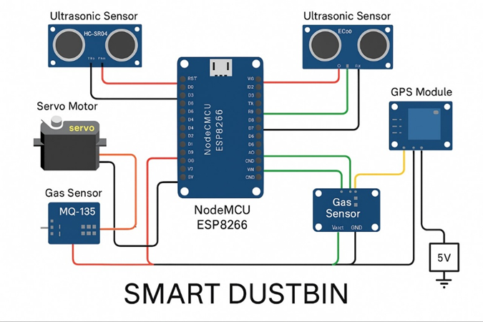

**Figure 3.1. Circuit(scematic) Diagram**

**3.3 BLOCK DIAGRAM**

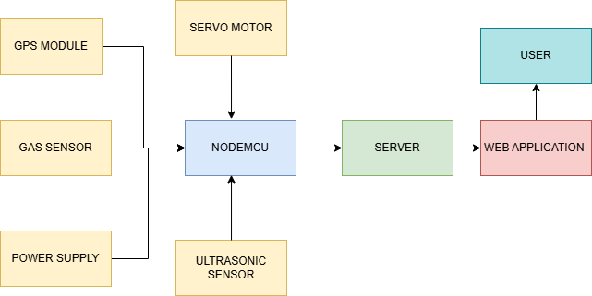

**FIGURE 3.2. BLOCK DIAGRAM**

**CHAPTER 4**

**HARDWARE DESCRIPTION**

**4.1 OVERVIEW**

EcoBinutilizes a variety of hardware components to create an intelligent, efficient, and hygienic waste management system. These components play key roles in monitoring waste levels, detecting odor, controlling the bin lid, and transmitting real-time data to a centralized platform. EcoBin’s hardware infrastructure ensures continuous operation, reduces environmental impact, and optimizes waste collection processes.

1. IoT Sensors

EcoBin is equipped with several IoT sensors that gather real-time data on waste bin status and environmental conditions. The ultrasonic sensor (HC-SR04) measures the fill level of the bin by emitting ultrasonic waves and calculating the distance to the waste. It provides continuous monitoring of bin capacity, sending real-time data for efficient waste collection scheduling. The gas sensor (MQ-135) detects hazardous gases, such as ammonia, methane, and carbon dioxide, which are produced by decaying organic waste. This sensor triggers automatic deodorization when high concentrations of harmful gases are detected. The GPS module (NEO- 6M) tracks the location of the bin in real-time. The location data is crucial for optimizing waste collection routes and ensuring that bins in high-traffic areas are serviced promptly.

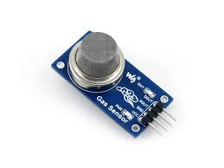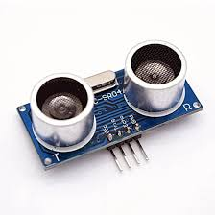

**FIGURE 4.1.GAS SENSOR FIGURE 4.2.ULTRASONIC SENSOR**

1. Microcontroller (NodeMCU-ESP8266)

The NodeMCU (ESP8266) serves as the central controller of EcoBin. It manages communication between the sensors, the deodorization system, and the cloud platform. The NodeMCU is responsible for data collection, processing, and transmission over Wi-Fi to ensure continuous monitoring and response. It also controls the servo motor to open the bin lid via gesture control.

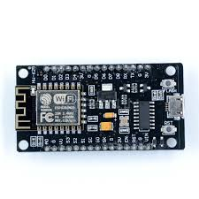

**FIGURE 4.3.NODEMCU**

1. Communication Protocols

EcoBin utilizes Wi-Fi to transmit data from the sensors and NodeMCU to the cloud-based platform. The use of Wi-Fi ensures reliable communication and real-time updates on bin status, odor levels, and location. The system leverages HTTP protocols to ensure easy integration and scalability within existing waste management systems.

4.Servo Motor

The SG-90 servo motor is responsible for the gesture-controlled lid mechanism. It allows users to open the bin lid with a simple hand gesture, preventing the need to physically touch the bin and reducing the spread of germs. The servo motor is controlled by the NodeMCU, ensuring hygienic waste disposal, particularly in public spaces.

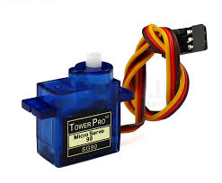

**FIGURE 4.4. SERVO MOTOR**

5.Power Supply Solutions

EcoBin is designed to operate in various environments, including off-grid or remote locations. The system uses energy-efficient power solutions, including solar panels to recharge batteries. This ensures that EcoBin operates continuously without requiring frequent manual recharging, making it both sustainable and cost-effective.

6.Deodorization System

The MQ-135 gas sensor continuously monitors air quality within the bin. If the sensor detects high levels of foul-smelling gases, it triggers an automatic deodorization process. This helps to maintain a clean, fresh environment around the bin, especially in areas with high organic waste content.

7.Gesture-Controlled Lid

EcoBin features a touchless, gesture-controlled lid. The system uses sensors (either ultrasonic or infrared) to detect hand movements and activate the servo motor, which opens the bin lid automatically. This hygienic feature ensures that users do not need to touch the bin, reducing the risk of contamination.

8.Data Storage and Alerts

Real-time data from the sensors in the EcoBin is continuously collected and transmitted to a cloud-based platform. This cloud platform acts as a central hub, where the data is processed, analyzed, and stored. The sensors, such as the ultrasonic sensor (HC-SR04), gas sensor (MQ-135), and GPS module (NEO-6M), send crucial information like the bin's fill level, the presence of hazardous gases, and the bin's location.

Once the data reaches the cloud platform, it is processed using advanced algorithms to assess the status of the bin. For example, if the ultrasonic sensor detects that the bin is near full, or if the gas sensor detects an increase in harmful or foul-smelling gases like ammonia or methane, the system triggers an automatic response. The cloud platform can then initiate actions like activating the deodorization system or notifying the waste management team.

9.Smart City Network Integration

EcoBin is designed to be compatible with smart city systems, allowing integration with broader urban waste management frameworks. The data collected by EcoBin can be used for dynamic routing of waste collection trucks, improving operational efficiency and reducing environmental impact by minimizing unnecessary travel.

In conclusion, the hardware components of EcoBin work together to create an efficient, hygienic, and scalable solution for modern waste management. By leveraging IoT sensors, real-time data transmission, and automation, EcoBin helps optimize waste collection processes and contributes to cleaner, healthier urban environments.

**CHAPTER 5**

**SOFTWARE DESCRIPTION**

**5.1 PROCEDURE TO CREATE A PROJECT**

Define Specifics:

Creating a project like EcoBin involves several steps, including setting up the development environment, designing the architecture, implementing features, and deploying the application. Here’s a high-level procedure to create a smart waste management system like EcoBin using Arduino, MQ-135 gas sensor, ultrasonic sensor, GPS module, NodeMCU (ESP8266), and servo motor:

## Step 1: Set Up the Development Environment

Using the Arduino IDE and configure it for the required hardware platforms (e.g., NodeMCU for the ESP8266). Set up a new project in the Arduino IDE, including the necessary libraries for the sensors and actuators (MQ-135, ultrasonic sensor, GPS, servo motor).

* Install libraries for each sensor (e.g., Ultrasonic, SoftwareSerial, Servo, etc.).
* Ensure that NodeMCU (ESP8266) is connected and recognized in the Arduino IDE.

## Step 2: Design the Architecture

Define the data flow from sensors (ultrasonic sensor, MQ-135, GPS) to the cloud platform or local storage system.

* Design RESTful API endpoints or WebSocket connections for communication between the Arduino and the cloud system.
* Set up the backend, such as Node.js and MongoDB, to handle and store data from the sensors (fill levels, odor concentration, GPS data).
* Plan the front-end architecture for the web interface, ensuring that data can be visualized in real-time (for instance, using tools like React.js and D3.js for visualizing data).
* Design a responsive dashboard for waste management authorities or users to monitor sensor readings, bin status, location tracking, and trigger notifications.

## Step 3: Implement Features

Implement hardware features using Arduino code:

* Configure the ultrasonic sensor to monitor the fill level of the bin.
* Use the MQ-135 gas sensor to detect odor or air quality inside the bin.
* Track the location using the GPS module (Neo-6m) to monitor bin locations and send updates.
* Integrate the servo motor to open the bin lid based on gestures or a control signal from the web interface.
* Set up communication between the NodeMCU (ESP8266) and the cloud platform or local server to send and receive sensor data in real-time.

Develop the cloud-based platform or web interface to:

* Display sensor data (e.g., fill level, gas concentrations, GPS location) in real- time.
* Implement notification features for alerts such as "Bin Full" or "High Odor Detected".
* Allow remote control for opening/closing the lid using the web interface.
* Enable waste management authorities to optimize collection schedules based on real-time data.

## Step 4: Software Development(Future Scope)

* Develop the backend using Node.js and Express.js to handle sensor data, perform basic data processing, and store it in MongoDB.
* Develop the frontend interface with React.js to display data visualizations and interactive dashboards for monitoring and control.
* Implement user authentication and authorization for accessing sensitive data and operations.
* Create APIs to communicate with the Arduino and send data to/from the cloud platform.

## Step 5: Documentation

* Document the hardware setup, including wiring diagrams, pin configurations, and sensor placement.
* Provide detailed code documentation for Arduino sketches and the backend.
* Create installation manuals, user guides for operating the system, and troubleshooting instructions.

## Step 6: Deployment

* Deploy the backend to a cloud platform such as AWS, Microsoft Azure, or Google Cloud.
* Ensure the system is integrated with real-time monitoring and control features accessible by waste management authorities.
* Set up Continuous Integration (CI) and Continuous Deployment (CD) pipelines to automate updates and deployments of the backend and web interface.

## Step 7: Maintenance and Support

* Regularly update and maintain the software based on feedback from users and ongoing developments in technology.
* Fix bugs, implement new features, and optimize performance as required.
* Monitor the system for errors or failures, and provide support to users and administrators.

## Integration and Testing:

1. **Hardware Integration**

* Assembly: Assemble all hardware components including sensors, actuators, and NodeMCU.
* Power-up Test: Test individual components like the sensors and servo motor to verify correct connections.

## Software Integration

* Code Integration: Integrate the hardware code with the cloud backend and front-end system.
* Functionality Check: Ensure that data from the sensors is being sent and received correctly.

## System Testing

* Basic Functionality Test: Verify that the sensors are accurately detecting fill levels, odor levels, and location.
* Autonomous Navigation Test: Ensure the system can send automated alerts based on sensor readings.
* Wifi Control Test: Verify that the NodeMCU can connect to Wi-Fi and send/receive data.
* Sensors Life Test: Test the durability and accuracy of sensors over extended periods.

## Performance Evaluation

* Speed and Accuracy: Measure how quickly the data is collected, processed, and transmitted to the cloud.
* Reliability and Availability: Ensure that the system can function continuously without failure.
* Scalability: Evaluate how the system handles multiple bins or sensors deployed in an area.

## User Acceptance Testing (UAT)

* Gather feedback from users on the functionality and usability of the system.
* Implement iterative improvements based on user feedback.

## Documentation and Deployment

* Documentation: Ensure that the setup, usage, and maintenance of the

system are well-documented.

* Deployment: Make the system ready for use in real-world waste management applications.

## Documentation and Reporting:

* **Detailed Guides:** Installation and configuration manuals for hardware and software components.
* **Project Reports:** Comprehensive reports on development, testing, and deployment phases, including a summary of challenges and solutions. **Launch and Support:**
* **Deployment:** Ensure the system is ready for user installation and operation in the field.
* **Customer Support:** Provide assistance, troubleshooting, and system updates post-launch.

## Continuous Improvement:

* **Updates:** Regular software updates to add new features, security patches, and performance improvements.
* **User Feedback:** Continuously gather and analyze user feedback to enhance the system and add new functionalities.

**5.2 FLOWCHART**

The flowchart outlines a systematic approach for developing a smart waste management system like EcoBin. It begins with setting up the development environment using the Arduino IDE and necessary libraries for hardware like NodeMCU and sensors. Next, it moves to designing the system architecture, including backend, frontend, and data flow. The third step focuses on implementing hardware features such as sensor configuration and servo motor integration, followed by software development involving backend (Node.js), frontend (React.js), and authentication. Documentation and deployment are addressed next, ensuring that the system is well-documented and deployed on a cloud platform for real-time monitoring. Maintenance and support ensure continuous improvement through updates and user support. Finally, the integration and testing phase ensures the system’s reliability, accuracy, and performance through thorough hardware/software testing and user feedback incorporation. 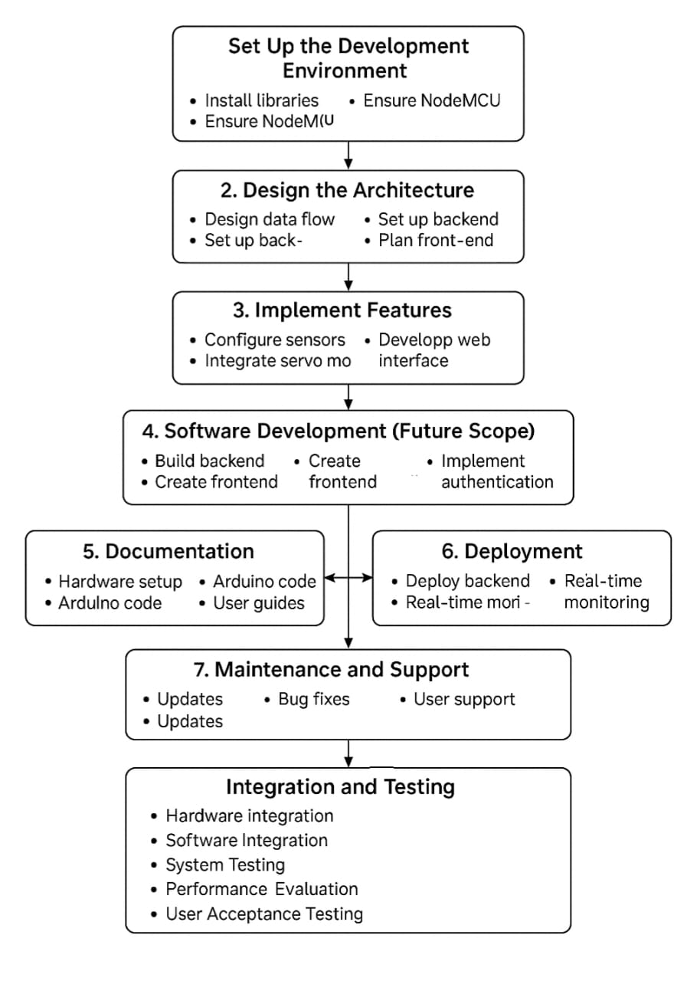 **FIGURE 5.1.FLOWCHART**

# CHAPTER 6

# RESULTS AND IMPLEMENTATIONS

EcoBin represents an advanced approach to waste management by integrating the power of IoT sensors, smart communication, and automation to optimize waste collection and ensure cleaner urban environments. The project is built upon the integration of several cutting-edge components like the MQ-135 gas sensor, ultrasonic sensor, GPS module, NodeMCU (ESP8266), and servo motor, providing a reliable and efficient solution for modern waste management challenges.

The system operates by leveraging multiple sensors to monitor and report various parameters related to waste bins. These sensors collect real-time data such as the fill level of the bin, air quality inside the bin, and even the geographic location of the bin. This data is sent to a central server or cloud platform, where it can be analyzed and acted upon.

# FEATURES

1. Location

EcoBin is equipped with a GPS module (Neo-6M), which continuously tracks the geographic location of the waste bins. This feature ensures that waste management authorities can monitor bin positions in real-time, making the waste collection process more efficient and ensuring timely pickups. The integration of GPS data helps optimize waste collection routes, reducing fuel consumption and carbon emissions.

1. Air Quality

The MQ-135 gas sensor integrated into EcoBin monitors the air quality inside the waste bin by detecting odor levels and the presence of harmful gases. This helps to identify bins with high levels of odor or potential hazardous gases, triggering alerts for waste collection authorities to act immediately. It also aids in reducing unpleasant odors in urban areas and promoting cleaner surroundings.

1. Bin Occupancy

The ultrasonic sensor measures the fill level of the waste bin by emitting sound waves and measuring the time it takes for the waves to bounce back. This data helps determine when a bin is full and needs to be emptied. By continuously monitoring bin occupancy, EcoBin ensures that bins are emptied at the optimal time, preventing overflow and reducing the chances of waste spillage in public spaces.

1. Gesture Control Open/Close

EcoBin features a servo motor that allows users to control the opening and closing of the waste bin’s lid through gesture control or remote commands. This feature ensures hands-free operation, promoting hygiene and convenience.The lid opens automatically when a user approaches or uses the gesture control feature, reducing physical contact and improving sanitation in public spaces. It also adds a level of automation to the waste management system, providing ease of use for people of all ages.

* 1. **PROTOTYPE MODEL**

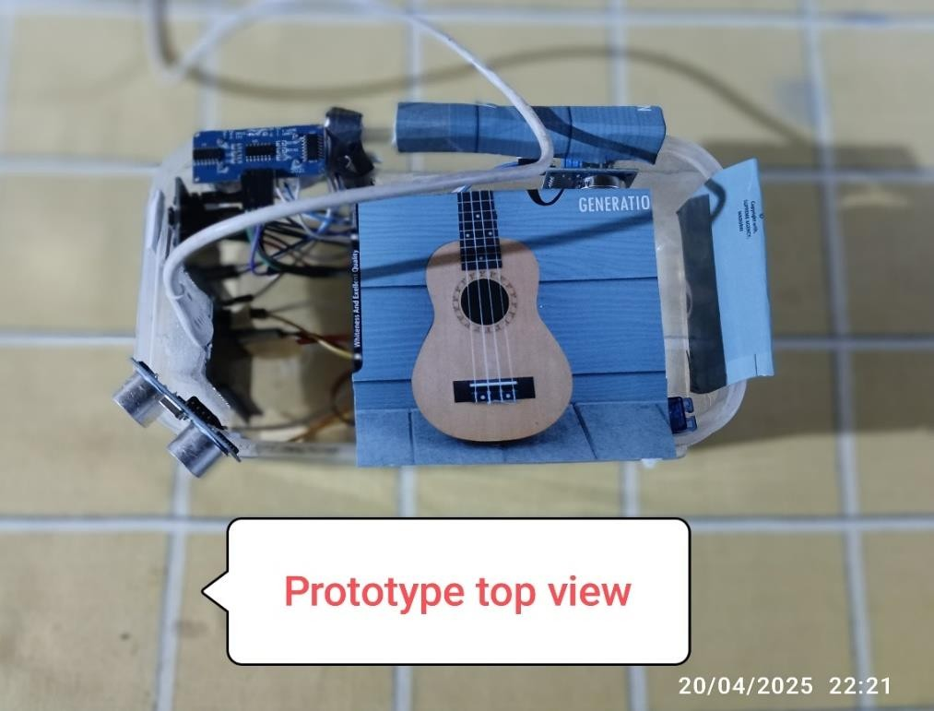

**FIGURE 6.1.PROTOTYPE TOP VIEW**

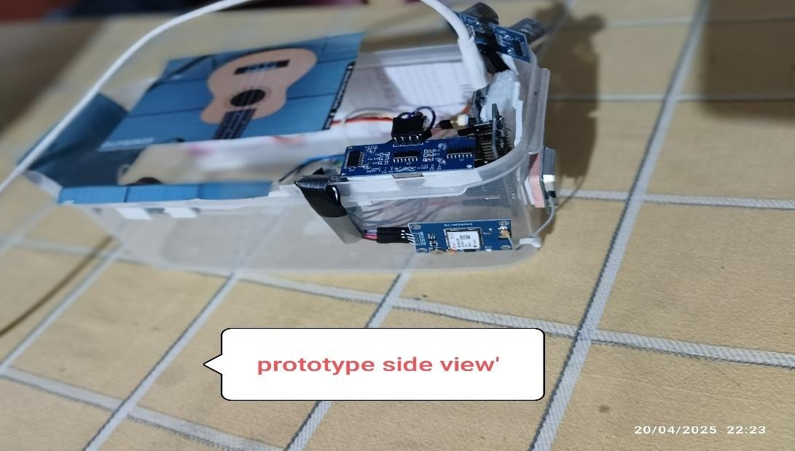

**FIGURE 6.2.PROTOTYPE SIDE VIEW**

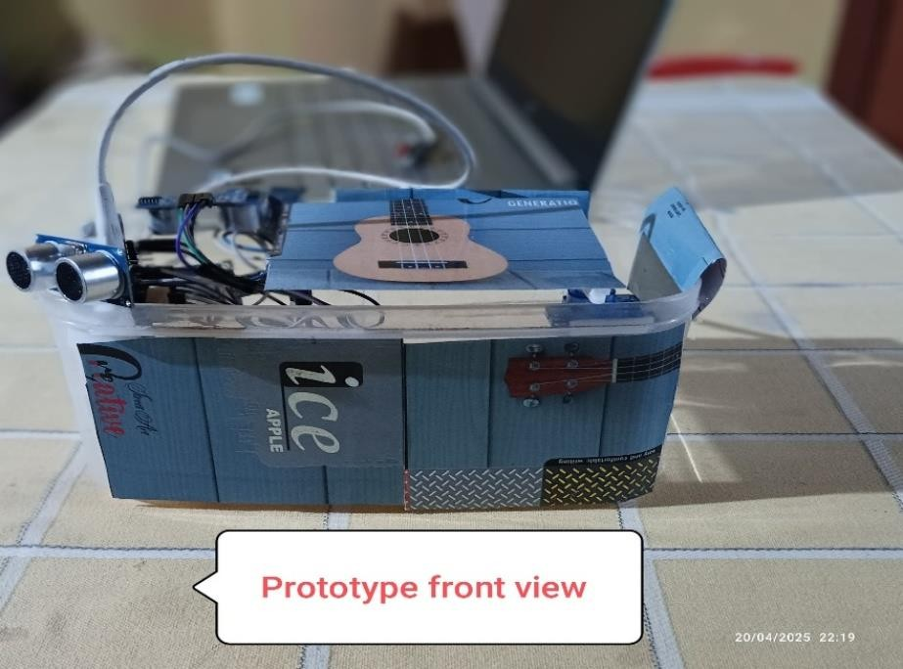

**FIGURE 6.3.PROTOTYPE FRONT VIEW**

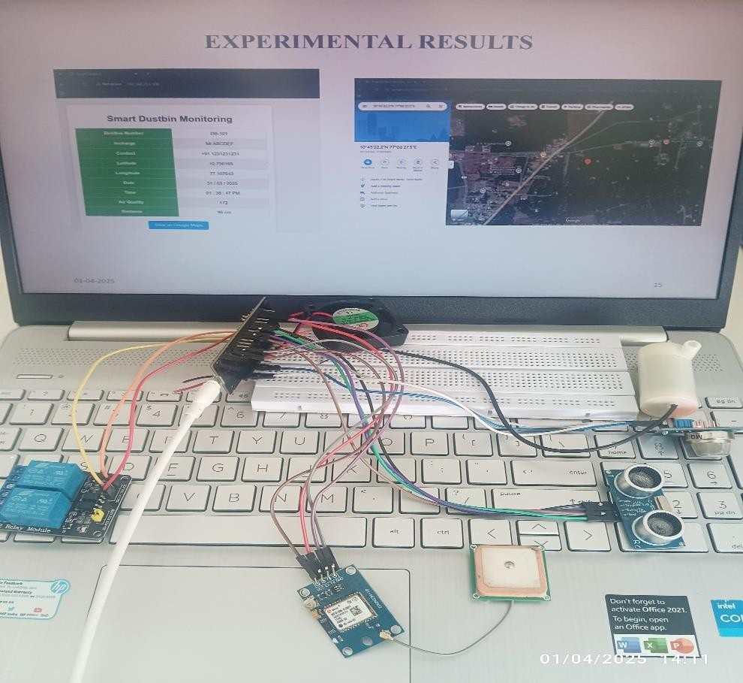

**FIGURE 6.4.HARDWARE AND SOFTWARE PROTOTYPE**

* 1. **OUTPUT**

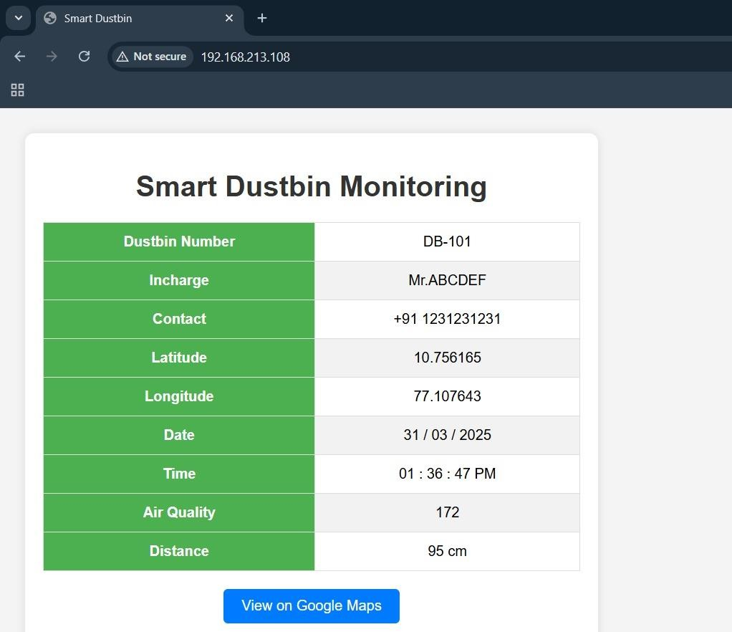

**FIGURE 6.5.REAL-TIME INTERFACE OF SMART DUSTBIN MONITORING SYSTEM**

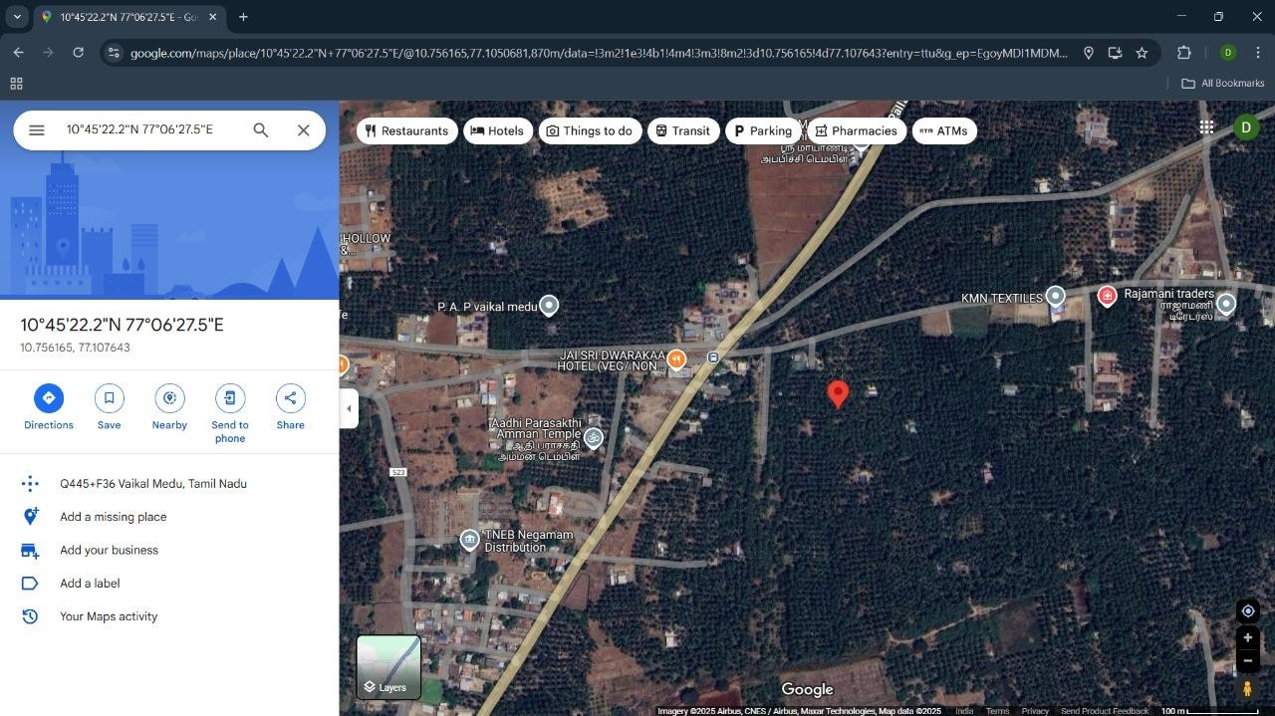

**FIGURE 6.6.LOCATION OF DUSTBIN**

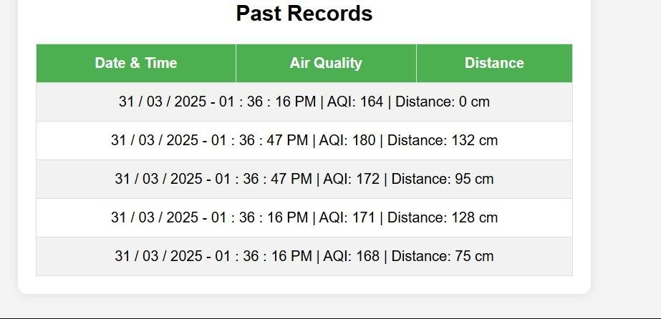

**FIGURE 6.7.RECORDED AIR QUALITY INDEX AND DISTANCE READINGS OVER TIME**

The prototype and output images of EcoBin effectively illustrate the practical realization of its smart waste management capabilities. From detecting waste levels and air quality to enabling touchless access via gesture control and tracking location through GPS, each function has been successfully implemented and demonstrated. These outputs validate the reliability and efficiency of the EcoBin system, highlighting its suitability for integration into smart city infrastructures.The results affirm the system’s potential to promote cleaner, more efficient, and technologically advanced waste disposal practices.

# CHAPTER-7 CONCLUSION AND FUTURE SCOPE

The EcoBin project represents a transformative step in the evolution of waste management systems by incorporating advanced smart technologies to create a solution that is both efficient and hygienic. In modern urban environments, traditional waste disposal methods often struggle to keep up with increasing population densities, leading to overflowing bins, poor hygiene, and inefficient waste collection schedules. EcoBin addresses these challenges by embedding features such as GPS-based location tracking, real-time bin occupancy monitoring, odor detection using the MQ-135 sensor, and even gesture-based lid operation. Additionally, the system includes voice recognition commands, adding an extra layer of hands-free interactivity. These innovations work together to form a comprehensive solution that enhances both the functionality and user experience of public waste disposal systems. By providing automation and data-driven insights, EcoBin elevates the standard for cleanliness, convenience, and efficiency in urban spaces.

One of the key features of EcoBin is its ability to continuously transmit data to a central platform using IoT sensors. These sensors track parameters such as the fill level of the bin, surrounding air quality, and the presence of unpleasant odors. This information is updated in real-time and sent wirelessly to a cloud-based system where waste management authorities can monitor conditions across a network of bins. The benefits of this system are multifold: collection teams no longer need to rely on rigid, pre-defined schedules but can respond dynamically to actual demand. This ensures that full bins are emptied before they overflow, while bins that are only partially filled are not collected prematurely, thereby saving time, fuel, and manpower. The real-time insights enable better planning and faster interventions when problems arise, ensuring the cleanliness and operational readiness of each bin location.

Beyond efficiency, EcoBin significantly enhances hygiene standards in public waste disposal. Touchless interaction is a cornerstone of the system, reducing the risk of germ transmission that typically occurs when multiple users physically touch bin lids. The gesture-controlled lid mechanism allows users to open the bin simply by waving their hand near a sensor, eliminating the need for direct contact. Similarly, voice commands can be used to operate the bin, adding a layer of accessibility for users with disabilities or those concerned with hygiene. This is particularly important in times of public health crises such as pandemics, where minimizing touch points in public spaces becomes critical. The odor detection system, powered by the MQ-135 gas sensor, plays a crucial role in environmental quality by sensing foul smells that indicate decomposing organic waste. When a certain threshold is reached, the system automatically activates a deodorization unit, helping maintain a pleasant and sanitary environment around the bin.

EcoBin also incorporates location intelligence into waste management through its built-in GPS module. This allows waste management teams to track the position of each bin in real-time, which is useful for inventory management and operational planning. The ability to view the exact location and status of each bin enables route optimization for collection vehicles, which reduces fuel consumption, lowers emissions, and minimizes operational costs. Over time, data collected from the system can reveal patterns in waste generation and accumulation across different neighborhoods. This can inform decisions on where to place additional bins or increase collection frequency. In areas with high foot traffic or commercial activity, for instance, bins may need to be emptied more often. EcoBin's analytics provide actionable insights to support these decisions, making the entire system more adaptive and responsive to changing urban conditions.

Looking ahead, the EcoBin system offers significant potential for future enhancements. One promising development is the integration of solar panels to power the sensors and control systems. This would make EcoBin a self-sustaining, eco-friendly solution suitable for deployment in remote or underserved regions where electricity may be unreliable or unavailable. Solar-powered operation also aligns with the broader goals of sustainability and green infrastructure. Another future direction is the application of machine learning algorithms to the collected sensor data. By analyzing historical trends and environmental factors, the system could predict waste generation patterns and automatically adjust collection schedules to meet demand. This predictive capability would push efficiency even further, allowing for truly intelligent waste management systems that adapt in real time to human behavior and environmental conditions.

The scope of EcoBin can also be extended through integration with mobile applications and cloud-based dashboards. Waste management personnel could receive push notifications about full bins, odor alerts, or equipment malfunctions directly on their devices, enabling quick and targeted responses. Residents and businesses might also be able to use a public-facing version of the app to report issues, check air quality readings, or even find the nearest available bin. Such digital connectivity not only empowers users but also enhances transparency and accountability in waste management services. Furthermore, as cities invest in smart infrastructure, EcoBin can become a part of the larger Internet of Things (IoT) ecosystem. Integration with other urban systems—such as traffic management, sanitation, and environmental monitoring—would enable coordinated operations that are more efficient and sustainable on a city-wide scale.

EcoBin’s modular and scalable design ensures that it can be adapted to different use cases, whether in residential neighborhoods, commercial districts, or large public events. Its flexibility allows municipalities to deploy it at various scales, from individual streets to entire cities. Additionally, the data collected by EcoBin can contribute to public policy development, urban planning, and environmental research. By creating a feedback loop between the physical environment and digital infrastructure, EcoBin not only improves waste collection processes but also contributes to smarter urban governance.

EcoBin stands out as an intelligent, adaptable solution that transforms the way waste is managed in modern cities. It prioritizes hygiene, promotes environmental responsibility, and enables a more efficient use of resources through real-time data and automation. As the challenges of urbanization, climate change, and public health continue to grow, solutions like EcoBin become increasingly vital. With its potential for integration, scalability, and innovation, EcoBin offers a vision of cleaner, smarter, and more sustainable cities for the future.

In conclusion, EcoBin is an innovative solution for urban waste management that offers sustainability, efficiency, and improved hygiene. As cities continue to embrace IoT and smart technologies, EcoBin’s potential to create cleaner, healthier urban environments becomes even more significant. The continued development of EcoBin could set the stage for more sustainable, intelligent waste management systems across the globe.

# REFERENCES

1. A. Smith, B. Johnson, C. Lee, et al., "Smart Waste Management Using IoT: A Review of Technologies and Applications," IEEE Access, vol. 8, pp. 234567- 234589, 2020.
2. R. Patel, S. Kumar, T. Nguyen, et al., "IoT-Enabled Smart Waste Bins: Design, Implementation, and Applications in Smart Cities," Journal of Environmental Management, vol. 13, no. 5, pp. 435-452, 2021.
3. S. R. Singh, M. Tiwari, P. Gupta, et al., "A Comprehensive Review of IoT-based Waste Management Systems," Waste Management, vol. 68, pp. 56-67, 2019.
4. L. Zhou, X. Zhang, W. Liu, et al., "IoT-Driven Smart Waste Management Solutions: Challenges and Opportunities," Journal of Sustainable Urban Development, vol. 8, no. 2, pp. 123-137, 2020.
5. K. Y. Chen, S. Wang, Z. Xie, et al., "Smart Dustbins for Real-Time Waste Collection and Management: A Review," International Journal of Environmental Science and Technology, vol. 17, no. 11, pp. 871-884, 2020.
6. M. K. Gupta, P. Sharma, S. Verma, et al., "Waste Management System Using IoT-Based Smart Dustbins," Journal of Environmental Engineering, vol. 24, pp. 789-798, 2019.
7. H. Lee, J. Park, Y. Kim, et al., "Smart Waste Management Using IoT and Cloud Computing: A Review," Environmental Engineering Science, vol. 36, no. 7, pp. 456-469, 2019.
8. J. G. Hughes, R. S. Taylor, and P. Johnson, "The Role of IoT in Smart City Waste Management: A Case Study," Urban Studies, vol. 12, pp. 94-112, 2021.
9. N. S. Kumar, S. P. Raj, and A. R. Alagarsamy, "Smart Garbage Monitoring System using IoT," International Journal of Pure and Applied Mathematics, vol. 118, no. 20, 2018.
10. R. K. Kodali and S. Mandal, "Smart Bin Implementation for Smart Cities," International Conference on Internet of Things and Applications (IOTA), 2016.
11. P. M. Patil and M. R. Patil, "Smart Waste Bin Monitoring System using IoT," International Research Journal of Engineering and Technology (IRJET), vol. 6, no. 5, 2019.
12. S. V. Raut, R. V. Shinde, "Smart City: Smart Waste Management System using IoT," International Journal of Computer Applications, vol. 179, no. 53, 2018.
13. M. F. A. Mahmud et al., "Smart Garbage Monitoring System for Waste Management using IoT," Journal of Physics: Conference Series, vol. 1529, 2020.
14. J. B. Patil and S. K. Patil, “IoT Based Garbage Monitoring System for Smart Cities,” IEEE International Conference on Computing Communication Control and Automation (ICCUBEA), 2017.
15. S. Longhi et al., "Solid Waste Management Architecture Using Wireless Sensor Network Technology," International Conference on New Technologies, Mobility and Security (NTMS), IEEE, 2012.
16. A. S. Suryawanshi et al., "Smart Dustbin: An Efficient Garbage Monitoring System," Springer Conference on Intelligent Computing and Communication, 2020.
17. S. Saponara and L. Petroni, Internet of Things and Smart Environments: Assistive Technologies for Sustainability, Springer, 2021.
18. H. A. Rahman et al., Smart Waste Management Technologies: Innovation, Assessment, and Management, CRC Press, 2022.

**Annexure**



|  |  |  |
| --- | --- | --- |
| **PROJECT TITLE** | ECOBIN – SMART WASTE MANAGEMENT WITH ODOR & GPS TRACKING | |
| **-PROGRAM** | B.E. ELECTRONICS AND COMMUNICATION ENGINEERING | |
| **PROJECT BATCH NUMBER** | 03 | |
| **BATCH MEMBERS** | 722822106002 | ABINAV G |
| 722822106023 | DHANUSHWARAN S |
| 722822106038 | HANSHAN KUMAR B |
| 722822106047 | INBAARUNRAJ D |
| **NAME OF THE SUPERVISOR** | Ms. T. Nivethitha, AP/ECE | |
| **NAME OF THE SDG GOALS MAPPED** | Goal 3 – *Good Health and Well-being*  Goal 6 – *Clean Water and Sanitation*  Goal 11 – *Sustainable Cities and Communities*  Goal 12 –*Responsible Consumption and production*  Goal 13 – *Climate Action* | |
| **MENTION THE SDG GOALS NUMBER** | 3, 6, 11, 12,13 | |
| **NAME OF THE TRL LEVEL** | Prototype Demonstration in Relevant Environment | |
| **MENTION THE TRL LEVEL** | TRL 6 | |

**POs & PSOs Mapping (Put a tick mark in the mapped PO’s & PSO’s):**

|  |  |  |  |  |  |  |  |  |  |  |  |  |
| --- | --- | --- | --- | --- | --- | --- | --- | --- | --- | --- | --- | --- |
| **Program Outcomes** | | | | | | | | | | | **Program Specific**  **Outcomes** | |
| **PO1** | **PO2** | **PO3** | **PO4** | **PO5** | **PO6** | **PO7** | **PO8** | **PO9** | **PO10** | **PO11** | **PSO1** | **PSO2** |
|  |  |  |  |  |  |  |  |  |  |  |  |  |

**Signature of the Supervisor (Name of the Supervisor)**

**Annexure**



**VENUE AND EXPENDITURE STATEMENT FOR THE PROJECT WORK**

|  |  |
| --- | --- |
| **Laboratory details where the**  **project is carried out** | **Project Lab, ECE** |
| **Software / Hardware details** | **Hardware:** NodeMCU-ESP8266, Servo Motor-SG 90**,** MQ-135 gas,  Ultrasonic sensor (HC-SR04), GPS module (NEO-6M), Breadboard,Jumber wires.  **Software:** Arduino IDE |

**Details of the Component and Expenditure**

|  |  |  |  |  |
| --- | --- | --- | --- | --- |
| **S. No** | **Name of the Component** | **Qty** | **Price / Unit in (Rs.)** | **Amount (Rs.)** |
| 1. | NodeMCU-ESP8266 | 1 | Rs. 650 / 1 | ₹650 |
| 2. | Ultrasonic Senor (HC-SR04) | 2 | Rs. 130 / 2 | ₹260 |
| 3. | GPS module (NEO-6M | 1 | Rs. 600 / 1 | ₹600 |
| 4. | MQ-135 Gas Sensor | 1 | Rs.280 / 1 | ₹280 |
| 5. | Servo Motor-SG 90 | 1 | Rs.170 / 1 | ₹170 |
| 6. | Jumper Wires | 25 | Rs.02 / 25 | ₹50 |
| 7. | Breadboard | 1 | Rs.150 / 1 | ₹150 |
| **Total** | | | | **₹2165** |

**(*Include any other charges which includes fabrication cost and others)**

**Signature of the student Signature of the Supervisor**

**(Names of the Student) (Name of the Supervisor)**